Tea ceremony experience with the Japanese historic building
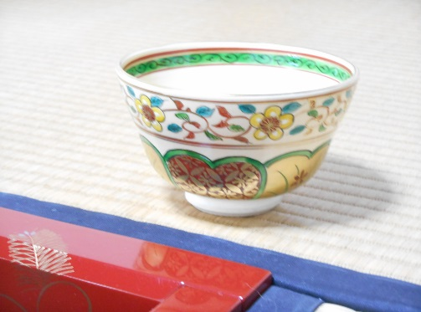
tea ceremony（Experience of the Japanese tea culture）

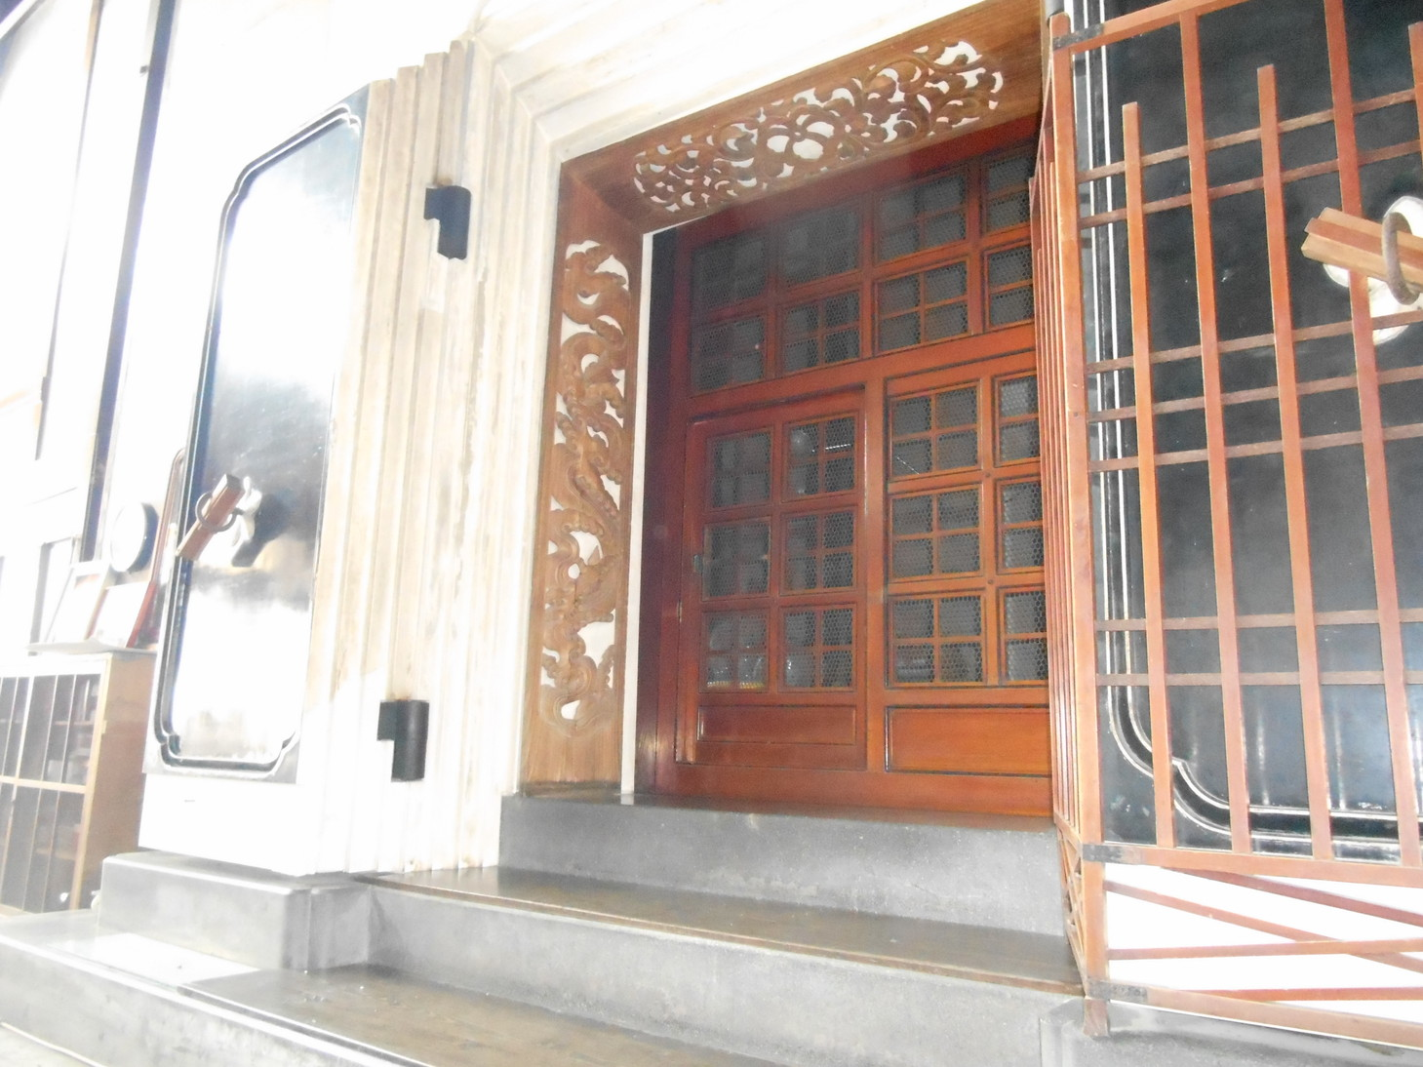
KURA（1869 completion）
（Incorporation of the lacquering ）
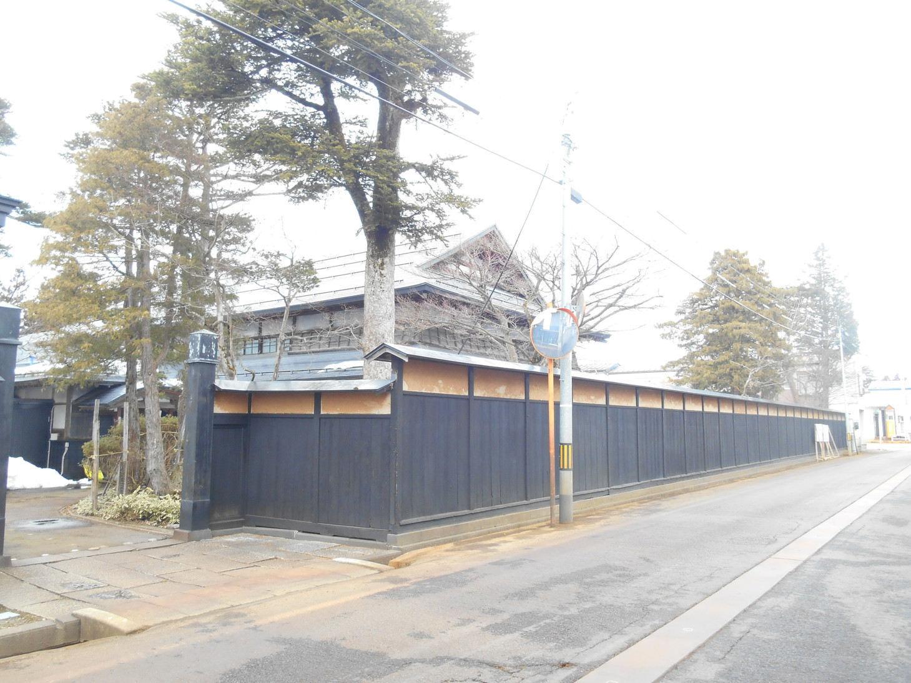
Black wall（1900 building）
（The wall which surrounds a business magnate）

Tea ceremony experience tour
date：April 27（thursday）13：00～15：00
Price: ¥2,000
Recruitment personnel: 10
place：Hongo mansion 、Kakumagawa, Daisen city
How to apply: April 26（wednesday）15：00
schedule
13：00 Leave west entrance、Omagari Sta by taxi
13：30 Arrive at Hongo mansion Experience of tea ceremony
14：30 Leave by taxi
15：00 Arrive at west entrance、Omagari Sta Finish
Application | FAX 0187-65-2488  E-mail：terui-k@toshi-seibi.com
Name | Nationality
What is your gender？ female male | date of birth
℡ | E-mail
sponsorship：Organized by Kakumagawa Regional Revitalization Council
http://www.kakumagawa-machi.com/

